Part 2(i) Hand in the values of the feedback gains K that you obtained using Simulink to balance

the inverted pendulum. You will be given no credit for using the state feedback gain

K in (1.6) or (1.8).

## MATLAB PLACE method

poles = [-1, -2, -3, -4]

K = [-0.693822224530531, 17.6774537226919, -9.06116259803147, 3.44045849686552]

## MATLAB LQR method

R = 0.1;

q = [10, 10, 1, 1]

K = [-10.0000000000003, 64.0183222816558, -21.1554476439027, 13.365507130453]

Poles = -17.5054016874784 + 0i

-3.87371824969042 + 0.995368557104881i

-3.87371824969042 - 0.995368557104881i

-1.23528536577762 + 0i

Part 2(ii) Hand in the plots of the poles of the feedback system with pole placement and LQR

method. Put them on separate plots, but with the same scale, same range, same

position of origin.

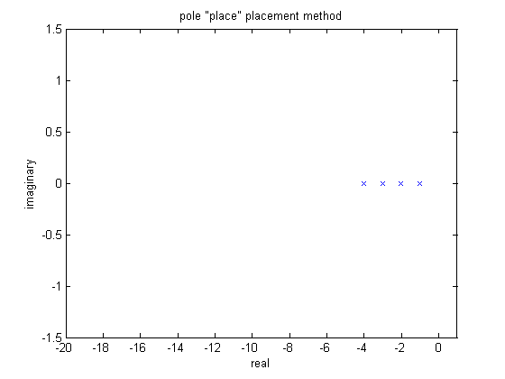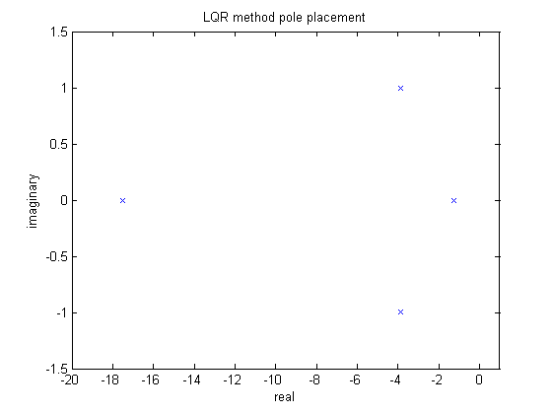

Part 2(iii) Hand in the plots for the angle _ for the both gains K that you used in Simulink on

the same graph. Hand in the plots for the position xc for the both gains K that you

used in Simulink on the same graph.

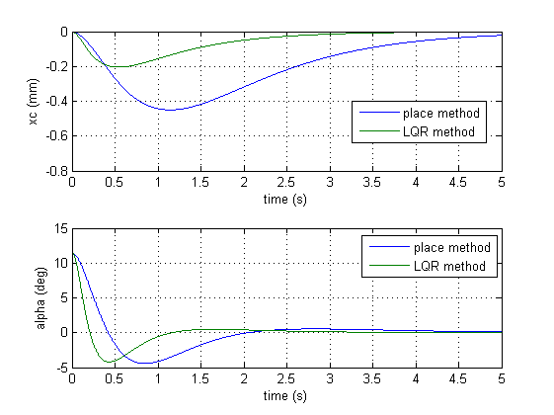

Part 3(i) Hand in your best values for the state gain K that you computed from Simulink.

R = 0.1

q = [1, 1, 0, 0, 10]

K = [-17.846969, 64.3913726, -23.0391798, 13.2126763, 9.9999999]

Part 3(ii) Hand in the plots of position and angle from the simulation.

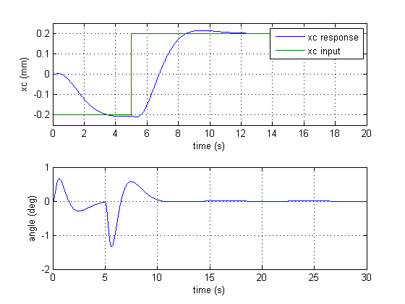

## Code:

clc; clear; close all;

run ('setup_lab_ip01_2_sip')

CART_TYPE = 'IP02';

IP02_LOAD_TYPE = 'WEIGHT';

PEND_TYPE = 'LONG_24IN';

IC_ALPHA0 = 0.2;

P1 = -1;

P2 = -2;

P3 = -3;

P4 = -4;

poles = [P1, P2, P3, P4]

K = place(A,B, poles)

sim('s_sip_lqr')

t = xc_out.Time;

xc = xc_out.Data;

alpha = alpha_out.Data;

figure(1)

subplot(2,1,1)

plot(t,xc)

xlabel('time (s)')

ylabel('xc (mm)')

grid on

hold all

subplot(2,1,2)

plot(t,alpha)

xlabel('time (s)')

ylabel('alpha (deg)')

grid on

hold all

figure(2)

plot(real(poles),imag(poles),'x')

xlabel('real')

ylabel('imaginary')

title('pole "place" placement method')

axis([-20 1 -1.5 1.5])

R = 0.1;

q1 = 10;

q2 = 10;

q3 = 1;

q4 = 1;

K = lqr(A,B, diag([q1, q2, q3, q4]),R)

sim('s_sip_lqr')

t = xc_out.Time;

xc = xc_out.Data;

alpha = alpha_out.Data;

figure(1)

subplot(2,1,1)

plot(t,xc)

xlabel('time (s)')

ylabel('xc (mm)')

legend('place method','LQR method')

grid on

hold all

subplot(2,1,2)

plot(t,alpha)

xlabel('time (s)')

ylabel('alpha (deg)')

legend('place method','LQR method')

grid on

hold all

poles = eig(A-B*K)

figure(3)

plot(real(poles),imag(poles),'x')

xlabel('real')

ylabel('imaginary')

title('LQR method pole placement')

axis([-20 1 -1.5 1.5])

clc; clear; close all;

run ('setup_lab_ip01_2_sip')

CART_TYPE = 'IP02';

IP02_LOAD_TYPE = 'WEIGHT';

PEND_TYPE = 'LONG_24IN';

IC_ALPHA0 = 0;

Ai = [A, zeros(4, 1);-1, 0, 0, 0, 0];

Bi = [B; 0];

R = 0.1;

q1 = 1;

q2 = 1;

q3 = 0;

q4 = 0;

q5 = 10;

K = lqr(Ai,Bi, diag([q1, q2, q3, q4, q5]),R)

sim('aae364pinv2')

t = xc_out.Time;

xc = xc_out.Data;

xc_cmd = xc_cmd_out.Data;

angle = angle_out.Data;

figure(1)

subplot(2,1,1)

plot(t,xc,t,xc_cmd)

axis([0 20 -0.25 0.25])

xlabel('time (s)')

ylabel('xc (mm)')

legend('xc response','xc input')

grid on

hold all

subplot(2,1,2)

plot(t,angle)

xlabel('time (s)')

ylabel('angle (deg)')

grid on

hold all